Q1.How can you output “Physics” and “Wallah” in two different lines

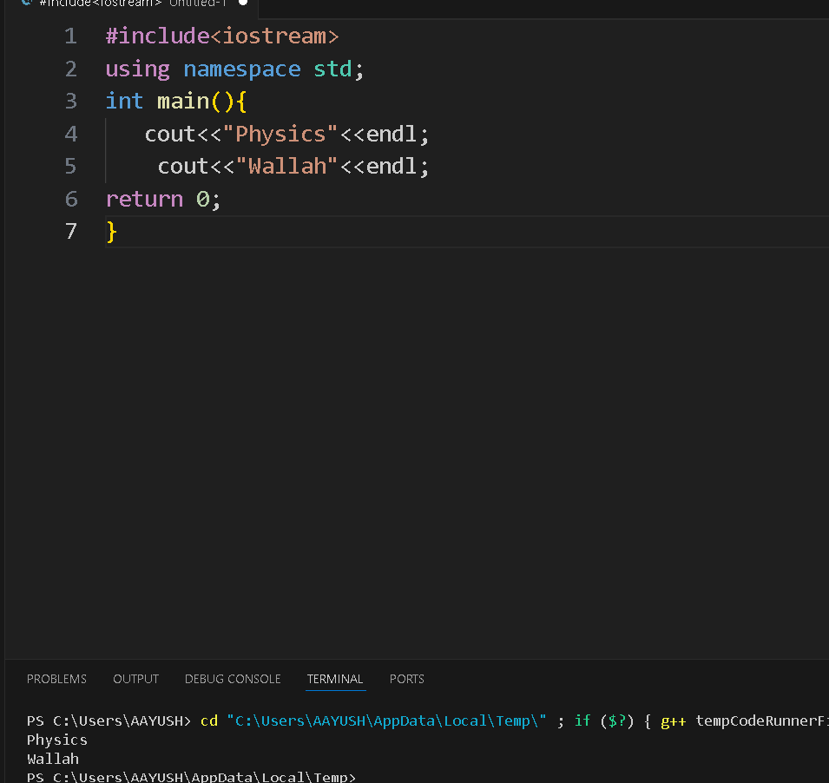

Q2. Print 10 using two positive number less than 6 in C++ as output

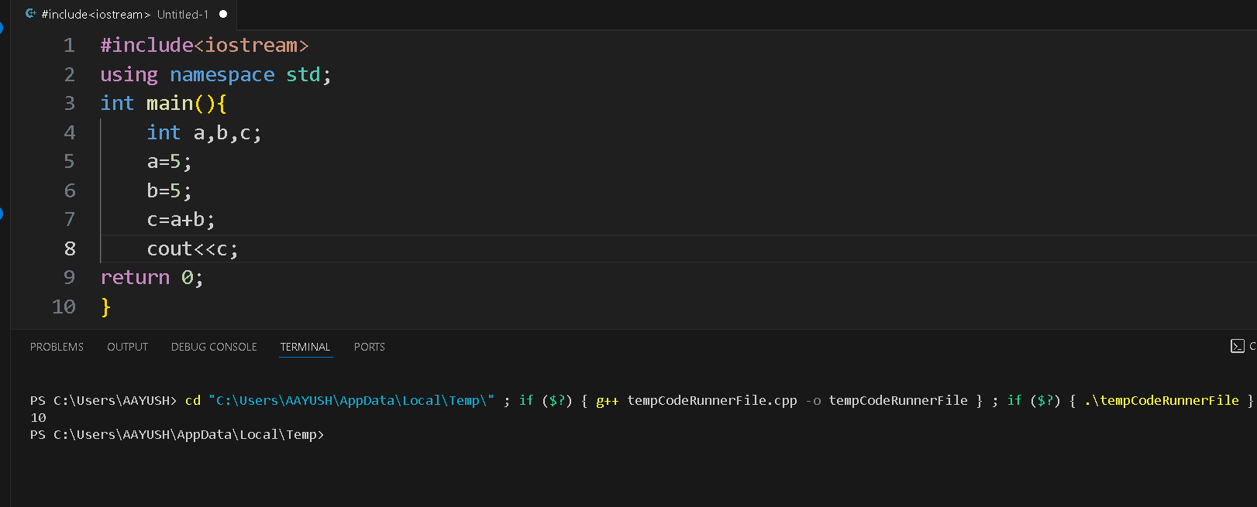

Q3 . How much space does following data types take.

1. int = 4 bytes
2. bool= 1 byte
3. float= 4 bytes

Q4.What is the output of this program.

void main(){

int a=4;

int b=5;

a++;b--;

cout<<++a<<” “<<b--;

}

It gave an error because it returns an int .

Q5.WAP to find the circumference of a circle with radius 10 in C++.

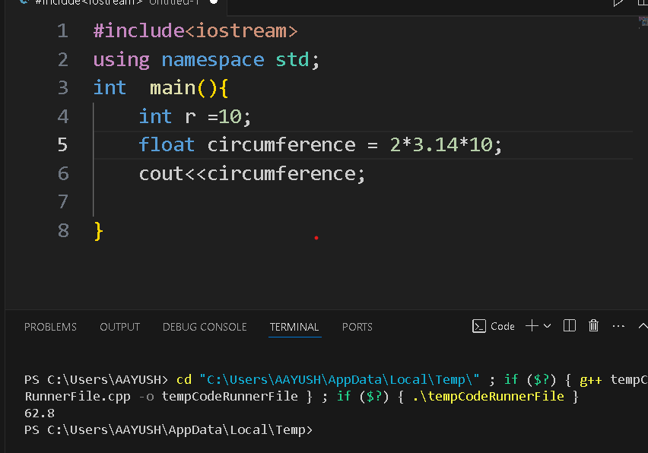

Q6. How many of these can be a variable name.

01PWskills

_Float

Int

Float

You will succeed

1